French Quarter
Restaurants, Bars, and Places of Assembly

Fire & Life Safety Inspection

Informational Packet
(This packet is for informational purposes only and does not replace any requirements or provisions indicated in local, state, or municipal ordinance, or any adopted building, fire, or life safety code.)


New Orleans Fire Department
317 Decatur Street
New Orleans, Louisiana 70130
504 658-4700
Table of Contents

- Purpose & Process

- Important Contact Numbers & Abbreviations

- Frequently Asked Questions

- Common Code Violations

- How to Prepare for Inspections

- Fire Safety Self-Inspection Checklist

- Fire Watch Detail Procedures

- Appeal Process

- Emergency Planning and Preparedness (Assembly Permits, Capacity/Occupant Load, Fire Evacuation and Fire Safety Plans)

- Sewerage & Water Board Sprinkler Connection Fees and Process

- Inspection and Permit Fee Schedule
Purpose

In a city known for its historic culture, eclectic music, cuisine and tourism, it is imperative to always consider public safety. In the wake of several national tragedies involving fires and overcrowding in places of assembly, the New Orleans Fire Department implemented a French Quarter Inspection Program to target this area most visited and enjoyed by locals and tourists. These inspections enabled us to identify hazards and structural deficiencies which could possibility jeopardize the safety of our citizens and visitors.

While the inspection program was deemed successful, the wrath of Hurricane Katrina temporarily redirected the enforcement efforts of our staff. In preparation for one of the most active tourist periods Post Katrina and the associated heightened national attention, the New Orleans Fire Department along with the Louisiana Office of State Fire Marshal is in the process of resuming its French Quarter Inspection Program.

This informational packet is the result of discussions with code enforcement officials and organizations representing bars, restaurants, hotel & lodging businesses in the French Quarter. The informational packet is designed to help French Quarter businesses to proactively participate in the code compliance efforts of the city of New Orleans. Our intent is to provide information that will provide knowledge and directions to businesses thus allowing NOFD and SFM inspectors the means to most effectively conduct inspections. Hopefully, these efforts will have a minimal negative impact to business owners and merchants in the French Quarter but ultimately ensure fire & life safety for all citizens and visitors.

Respectfully,

Elbert R. Thomas Jr.
Fire Prevention Chief

Process

- Inspections are conducted simultaneous with NOFD and SFM inspectors Mondays thru Fridays between 9:00 am and 4:00 pm, however, capacity checks will be randomly conducted during hours of business operations.

- NFPA 101 Life Safety Code, International Fire Code as amended, and other codes as referenced will be used to conduct inspections.

- Inspectors will cite violations and building representatives will be give written copies of inspection report.

- Inspection report will indicate timeframe in which violations must be corrected.

- It’s not always required but in complicated cases, it’s strongly recommended that building representatives/owners retain a design professional (licensed architect or engineer) to evaluate the structure and prepare a proposed plan of correction to bring the structure within code-compliance.

Important Contact Numbers

Name Telephone # Facsimile #
NOFD Headquarters (non-emergency) 658-4700
Fire Prevention Division 658-4770 565-7851
Public Affairs Division 658-4713
Deputy’s Office 658-4750
Detail Coordinator 658-4777
Inspections Supervisor 658-4772
Special Event & Plans Examiner 658-4774
Louisiana State Fire Marshal 219-4600
Department of Safety and Permits 658-7200
Vieux Carre Commission 658-1420
Historic District Landmark Commission 658-7040
Administrative Adjudication 658-2595
Sewerage & Water Board 529-2837
International Code Council 1 888 422-7233
Louisiana Restaurant Association 454-2277 454-2299
French Quarter Business Association 309-1423
Greater N.O. Hotel & Lodging Association 525-2264 525-9327

Abbreviations

NOFD- New Orleans Fire Department
SFM- State Fire Marshal
S&P- Safety & Permits
VCC- View Carre Commission
HDLC- Historic District Landmark Commission
BBSA- Board of Building Standards and Appeals
IFC- International Fire Code
IBC- International Building Code
NFPA101
or LSC- Life Safety Code
CTF’s- Confidence Testing Forms
AA- Administrative Adjudication

Frequently Asked Questions

- How can I obtain a copy of the Fire Code and Life Safety Code?
Copies of the 2006 International Fire Code may be obtained by contacting 1- 888-ICC-SAFE (422-7233); copies of the New Orleans amendments for International Fire Code can be purchased at the NOFD-Fire Prevention Division located on the 2nd floor of 317 Decatur St. Copies of the 2006 NFPA 101 Life Safety Code may be obtained by contacting 1-800-344-3555.

- Is there a fee for fire inspections?
Yes, fire inspection conducted by an employee of the New Orleans Fire Department shall be subject to fees as based on square footage of the inspectable area of the business as per fee schedule in section 105.8 of the Fire Code.
Note: a) There is no fee associated with business representatives completing the “Self-Inspection Checklist”.
b) When fire inspectors conduct an inspection, if the business has already received its annual inspection, an additional inspection fee would not be assessed; however, if the business has not received its annual inspection, an inspection fee would then be assessed.

- What permits are typically required?
A Use & Occupancy permit is required to legally occupy and use any commercial structure.
A permit is required annually to operate a place of assembly.
A signaling and suppression system permit is required to install, make alterations, or demolish any fire protection system such as fire alarm, sprinkler, standpipe, or hood system.

- How do I obtain capacity/occupancy load signs?
Contact NOFD-Fire Prevention Division @ 658-4770 or SFM @ 219-4600 to schedule an inspection.
Note: a) Capacity/Occupancy load signs are acceptable from New Orleans Fire Department, Safety & Permits, or State Fire Marshal.

- What to do if I want to change the use or change the layout of the structure or business?
Contact Safety & Permits @ 658-7200 to inquire what is required.

- When are Fire Watch Details required?
There are many references within the codes where certain activities require a fire watch. Example: inoperable fire protection systems, pyrotechnic displays, usage of open flames within an assembly, operation/storage of vehicles within an assembly, and certain activities not expressly stated in the “Code” but when in the opinion of the Fire Official a fire watch may be required.

- Who can conduct Fire Watch details?
Whenever it is essential for public safety in a place of public assembly or any other place where people congregate due to the number of persons, or the nature of the performance, exhibition, display, contest or activity, or inadequate signaling/suppression systems, the Fire Official may require the employment of one or more experienced New Orleans Fire Department firewatch personnel, to be on duty at such place. Said New Orleans Fire Department firewatch personnel shall be subject to the Fire Official’s orders at all times when so employed, and shall be in uniform and remain on duty during the times such places are open to the public, or when such activity is being conducted.

- What are the cost and/or fees for Fire Watch detail services?
Fire personnel are paid according to the following rates of pay as stipulated within the current Collective Bargaining Agreement:
  - Firefighter - $20.00/hr
  - Operator - $22.00/hr
  - Captain/Inspector - $25.00/hr
  - Chief - $28.00/hr

Note: All firewatch details shall be paid a minimum of four (4) hours.

A 10% Fire Watch Administrative Fee payable to the City of New Orleans is charged for each required fire watch as per fee schedule listed in the “Fire Code”.

- How and where can appeals to violations be made?
Whenever the owner of an alleged unsafe structure or alleged public nuisance does not agree with the order from the Fire Department, as to the corrections to be made, he shall have the right to appeal to the Board of Building Standards and Appeals within fifteen (15) days from the date of the order stating how he proposes to make the structure safe and, if required by the Board, shall submit detailed engineering analysis or recommendations accompanied by plans and specifications prepared by a Louisiana registered architect or a Louisiana registered civil engineer, or other substantiating data concerning the removal or other remedial steps to be taken to render the structure safe.

- Can I provide equivalencies or trade-offs for non compliance?
Yes, when the strict compliance with of the intent of the code cannot be made, the owner may appeal to the Board of Standards and Appeals and offer an alternative proposal that meets or exceeds the requirements of the code.
Common Code Violations
- Blocked exits
- No exit sign and/or exit lights out
- Doors locked during hours of occupancy
- Overcrowded and/or no occupant load sign posted
- Aisles not adequate
- Fire extinguisher not serviced or nonexistent
- Candles on tables in unsafe holders
- Electrical hazards and extension cord problems
- Decorations not flame retardant
- Non-flame retardant drapes
- Smoking
- Heating hazards
- Lack of panic hardware and/or door hard to open
- No emergency lighting or not tested
- Fire alarm testing, no record of testing
- Kitchen extinguishing systems not tested
- Kitchen hood has too much grease
- Deadbolts on exit doors with panic hardware
- Painted sprinkler heads
- Grease accumulation on filters and in ducts
- Hood system not serviced , or nonexistent
- Cluttered boiler room, electrical equipment room
- Tables or storage in exit paths
- Lack of 2nd means of egress
- Lack of approved egress from second floor
- Unenclosed stairway/vertical openings
- Doors do not swing in direction of egress
- Travel distance
- Improper storage
- Unauthorized/permitted construction changes to structure or change of use
How To Prepare for Inspections

- Ensure all required permits are current.

- Ensure capacity signs are current and posted.

- Ensure NOFD has copy of all current CTF’s (confidence testing forms) on all fire protection systems.

- Ensure all fire protection systems are 100% operable and properly tagged.

- Prepare/review/and enforce crowd control procedures.

- Ensure all exits and access to exits are maintained clear and obstructed.

- Be prepared to correct any violations immediately or for complicated cases get a plan of correction to NOFD and SFM with a reasonable time-line for completion of work.

- Annually review and complete the “Fire Safety Self-Inspection Checklist”.

Fire Safety
Self-Inspection Checklist
(This form should be completed at least once annually)

Instructions: Fill in all the information on the form. Walk through your occupancy to ensure the safety requirements on the checklist are fulfilled. If an item is complaint, check the “Yes” box. If an item is non-compliant, check the “No” box and work to remedy the problem. If an item does not apply, check the “N/A” box.

Access & Premises Yes No N/A
1. Is address number for building clearly visible from the street? ⁮ ⁮ ⁮
2. Is exterior fire department access obstructed? ⁮ ⁮ ⁮
3. Is combustible vegetation removed so as to not create a fire hazard? ⁮ ⁮ ⁮
4. Is a minimum 3 ft clearance maintained around fire hydrants? ⁮ ⁮ ⁮

Egress
5. Are the exit access and exit doors easily recognizable, unobstructed and
maintained functional? ⁮ ⁮ ⁮
6. If the main exit door is provide with a key locking hardware as allowed
by code, is there a sign above the door that states “THIS DOOR MUST
REMAIN UNLOCKED DURING BUSINESS HOURS”. ⁮ ⁮ ⁮
7. Are the other required exit doors readily operable from the inside without
the use of a key or special knowledge or effort? ⁮ ⁮ ⁮
8. Are the exits and exit enclosures free from storage of combustible
materials? ⁮ ⁮ ⁮
9. Are doors with self-closing hinges maintained in the closed position (not
blocked open)? ⁮ ⁮ ⁮

Electrical
10. Are all electrical outlets, switches and junction boxes properly covered
with cover plates and is the electrical system safe from any apparent
shock and/or other electrical hazards? ⁮ ⁮ ⁮
11. Are circuit breakers/fuses labeled so as to identify the area protected? ⁮ ⁮ ⁮
12. Is the area maintained clear at least 36” in front of electrical panel(s)? ⁮ ⁮ ⁮
13. Are extension cords used only for temporary use and not used as
permanent wiring? ⁮ ⁮ ⁮
14. Are extension cord(s) in good condition, properly grounded and of
appropriate gauge? ⁮ ⁮ ⁮

Emergency Lighting
15. If emergency lighting is provided, is it maintained in operable condition? ⁮ ⁮ ⁮
16. Is the means of egress illuminated when the building or structure is
occupied? ⁮ ⁮ ⁮

Emergency Planning, Preparedness, and Drills
17. Is a current “fire evacuation plan” and a “fire safety plan” available in the
workplace for reference and review by employees and copies furnished
to the fire department? ⁮ ⁮ ⁮
18. Is a current detailed seating plan, occupancy/capacity sign posted in a
conspicuous place? ⁮ ⁮ ⁮
19. Has an emergency evacuation drill been conducted, at least quarterly,
and records of drill maintained available on the premises? ⁮ ⁮ ⁮

Exit Signs
20. If exit signs are required, are they maintained illuminated or self-
luminous? ⁮ ⁮ ⁮
21. Does the back-up battery work (push the test button and the exit sign
should illuminate under battery power)? ⁮ ⁮ ⁮

Fire Alarm System
22. If the building is equipped with a fire alarm system, has the required
annual service of the fire alarm system been performed by a
State Fire Marshal licensing company? ⁮ ⁮ ⁮

Fire Extinguishers
23. Are fire extinguisher(s) properly mounted and is the travel distance
from all portions of the building to a fire extinguisher less than 75’ ? ⁮ ⁮ ⁮
24. Are all fire extinguishers visible and accessible (not blocked)? ⁮ ⁮ ⁮
25. Have the fire extinguisher(s) been serviced and tagged by a State Fire
Marshal licensing company within the last 12 months? ⁮ ⁮ ⁮

Fire/Smoke Separations
26. Are the fire/smoke separations (automatic smoke doors, fire doors,
firewalls, etc.) maintained and in working condition? ⁮ ⁮ ⁮

Fire Suppression Systems
27. Is the top of storage maintained a minimum 18 inches below sprinkler head
deflectors in fire-sprinklered areas? ⁮ ⁮ ⁮
28. If the building is equipped with a fire sprinkler system, has the required
annual service of the fire sprinkler system been performed with in the last
12 months by a State Fire Marshal licensing company? ⁮ ⁮ ⁮
29. In commercial cooking applications, has the hood suppression system
been serviced in the last six months and is the hood cleaned at intervals
to prevent the accumulation of grease? ⁮ ⁮ ⁮

Heat Producing Appliances (Open flame heaters are prohibited for use in Assembly occupancy)
30. If portable electric heaters are used, are they used safely? Also, are they
plugged directly into wall outlets and kept a minimum of 3’ away from
combustibles? ⁮ ⁮ ⁮
31. Did you know that open flame unvented heaters are prohibited for use in
a assembly occupancy? ⁮ ⁮ ⁮
32. Is the clearance between ignition sources, such as light fixtures, heaters,
and flame producing devices, and combustible storage maintained in an
approved manner? ⁮ ⁮ ⁮

Housekeeping
33. Is combustible rubbish that is stored in containers or rooms removed from
the building a minimum of once each working day? ⁮ ⁮ ⁮
34. Are oily rags or similar materials stored in metal, metal-lined or other
approved containers equipped with tight fitting covers? ⁮ ⁮ ⁮
35. Are combustible decorations flame retardant? ⁮ ⁮ ⁮

Permits
36. Is a current (within 12 months) operational permit for an assembly
posted in a conspicuous place or on file readily available at time of an
inspection? ⁮ ⁮ ⁮

Mechanical Hazards
37. Is the venting for exhaust products of combustion in tact for gas
appliances (like water heaters, furnaces, etc.)? ⁮ ⁮ ⁮
38. Is a minimum 3 feet clearance maintained between gas fired appliances
(such as water heaters, furnaces, etc.) and combustible materials? ⁮ ⁮ ⁮
39. Are rubbish containers over 5 1/3 cubic feet (40 gallons) provided with
lids and made of noncombustible construction? ⁮ ⁮ ⁮
40. Are dumpsters that are 1.5 cubic yards or more not stored inside the
building and placed more than 5’ from combustible walls, openings or
combustible roof eave lines? ⁮ ⁮ ⁮

Smoke Detection
41. If smoke detection is required or part of the fire alarm system, has
it been tested within the last year by a State Fire Marshal licensing
company? ⁮ ⁮ ⁮

Storage of Combustibles
42. Is the storage of combustible materials orderly? ⁮ ⁮ ⁮
43. Are combustible materials not stored beneath the building or structure? ⁮ ⁮ ⁮
44. Are the boiler rooms, mechanical rooms and electrical panel room
maintained without the storage or any combustible materials within? ⁮ ⁮ ⁮

Storage of Compressed Gas
45. If you have compressed gas containers (such as co2, helium, etc.) are
they chained to prevent falling? ⁮ ⁮ ⁮

Storage of Flammable & Combustible Liquids
46. Are quantities in excess of 10 gallons of flammable and combustible
liquids used for maintenance purposes and the operation of equipment
stored in liquid storage cabinets? ⁮ ⁮ ⁮

This Fire Safety Self-Inspection Form is intended to cover the most common items/hazards encountered while performing fire inspections in bars, restaurants, and assembly occupancies. It is not intended to be all comprehensive or replace specific code requirements not addressed on the form. If you have a specific code related question not addressed on this form, please contact NOFD-Fire Prevention Division or LA State Fire Marshals Office.
Fire Watch Detail Process
The following information is provided to describe the procedures for fire watch services within Orleans Parish.

- The New Orleans Fire Department enforces the (IFC) International Fire Code 2006 edition as amended and adopted by the N.O. City Council as Ordinance No. 22958 M.C.S; approved and signed by the Mayor on January 24, 2008.

- The “Code” defines a Fire Watch as, “Uniformed New Orleans Fire Department personnel subject to the Fire Official’s orders at all times when so employed. The term “fire watch” shall be synonymous with “standby firefighter” or “standby fire watch”.

- There are many references within the code where certain activities require a fire watch. Example: inoperable fire protection systems, pyrotechnic displays, usage of open flames within an assembly, operation/storage of vehicles within an assembly, and certain activities not expressly stated in the “Code” but when in the opinion of the Fire Official a fire watch may be required.

- Once a fire watch is deemed necessary for an activity, the “Detail Coordinator” determines the rank and quantity of personnel required for the fire watch based upon the activities and code deficiencies that exist within the structure.

- The Detail Coordinator prepares a letter of agreement between the organizations/ representative needing the fire watch and the fire watch personnel.

- Once the letter of agreement is signed, the “Detail Coordinator” forwards a fire watch workorder to the deputy’s office. Utilizing a rotation list, the deputy’s office hires the specified fire personnel for the fire watch services.

- The personnel hired for the fire watch services pick-up a copy of the workorder and a fire department radio then reports to the site to perform fire watch services as stipulated on the workorder.

- Fire personnel are paid according to the following rates of pay as stipulated within the current Collective Bargaining Agreement:
  - Firefighter - $20.00/hr
  - Operator - $22.00/hr
  - Captain/Inspector - $25.00/hr
  - Chief - $28.00/hr

Note: All firewatch details shall be paid a minimum of four (4) hours.

- A 10% Fire Watch Administrative Fee payable to the City of New Orleans is charged for each required fire watch as per fee schedule listed in the “Fire Code”.

- It is the responsibility of the business/organization needing the fire watch services to provide and process IRS 1099 forms for the fire watch personnel.
2006 IFC

301.3 Standby Firewatch Personnel. Whenever it is essential for public safety in a place of public assembly or any other place where people congregate due to the number of persons, or the nature of the performance, exhibition, display, contest or activity, or inadequate signaling/suppression systems, the Fire Official may require the employment of one or more experienced New Orleans Fire Department firewatch personnel, to be on duty at such place. Said New Orleans Fire Department firewatch personnel shall be subject to the Fire Official’s orders at all times when so employed, and shall be in uniform and remain on duty during the times such places are open to the public, or when such activity is being conducted.

Louisiana Office of State Fire Marshal
REQUIREMENTS FOR TEMPORARY FIRE WATCH
In the event that a required fire alarm/sprinkler system is determined to be not in proper working order for more than four (4) hours in a twenty-four (24) hour period or is not installed, the following actions shall be taken by the facility or the building shall be vacated:
1. Notify the State Fire Marshal District Office, the local fire department and all facility personnel, in writing, that the fire alarm/sprinkler system is not operational.
2. Establish a temporary fire watch by individuals* who are dedicated solely to fire watch duty.
3. Provide fire watch personnel with a means of identifying themselves as authorized representatives of the facility.
4. Each route to be covered by fire watch personnel shall be designated by the facility.
5. The route shall be explicitly defined to ensure that the fire watch personnel patrols the correct area.
6. The fire watch personnel assigned to each route shall be provided with instructions, all details regarding the route, and the functions to be carried out in covering the route.
7. Fire watch personnel shall make rounds at one (1) hour intervals. When operations in the property normally are suspended, officers shall make rounds hourly. During the rounds, the fire watch personnel shall make a thorough inspection of all buildings or spaces including concealed areas, such as attics, unoccupied storage areas, etc. Fire watch personnel shall sign a log sheet maintained in the facility main office or other location approved by this office or fire department. Log sheet shall state begin time and end time of each individual round.
8. Procedures shall be established for orderly conduct of the operations at the property, including procedures for fire loss prevention both by employees of the property protected and by outside contractors, and the prompt reporting of any fires discovered by calling the public fire department and the fire brigade of the property (if available on the shift).
9. Each facility shall establish programs for fire watch personnel to ensure they are familiar with the property being protected, including:
(a) All buildings, occupancies, and hazards.
(b) Fixed fire protection systems.
(c) Manual and automatic detection and alarm systems.
(d) Portable fire protection equipment.
(e) Emergency shutdown procedures and equipment for which they are responsible.
(f) The facility emergency action plan.
10. Each facility shall ensure that fire watch personnel are familiar with the site specific emergency plans for dealing with fires and other emergencies.
11. Each facility shall ensure that fire watch personnel are familiar with the procedures to follow in the recognition and reporting of an emergency, including:
(a) When and how to use radio equipment, telephone, and private or public alarm boxes to summon aid.
(b) How to notify the fire brigade, the municipal fire department, and other emergency response organizations.
(c) The personnel to be contacted.
12. Fire watch personnel shall be provided with a means for continuous communication (i.e., two-way radio; walkie-talkies; etc.) with a constantly attended location such as the administrative office where a public address announcement can be made throughout all buildings in the event of an emergency.**
13. Each facility manager/administrator shall ensure that:
(a) Fire watch personnel are not permitted to change the time record charts.
(b) The changing and review of time record charts is done by the manager/administrator or the manager/administrator’s responsible designee.
(c) Time record charts of fire watch personnel are promptly reviewed.
(d) Files are maintained for review by representatives of any authority having jurisdiction.
(e) All irregularities are investigated, recorded, and corrective action is taken.
14. A continuously updated directory of names, telephone numbers, and other information to assist in making emergency calls shall be kept at the facilities administrative office. This directory shall include the telephone numbers of key facility personnel to be notified in an emergency, fire, police and emergency medical service departments, and other outside agencies needed in an emergency.
PLEASE BE ADVISED THAT THE DURATION OF THE TEMPORARY FIRE WATCH WILL BE DETERMINED ON A CASE BY CASE BASIS.
*It shall be the responsibility of management to ensure that fire watch personnel are capable of performing all functions of a fire watch as defined in this document.
Note: Local ordinances may require the fire department having jurisdiction to conduct the fire watch; however, the fire watch guidelines, as stated in this document, shall be implemented.
**Buildings or areas of the building without public address systems, there shall be a sufficient number of fire watch personnel to initiate evacuation procedures throughout the building in an orderly manner.
(Revised 10/5/05)
Appeal Process

2006 IFC

SECTION 108 – BOARD OF BUILDING STANDARDS AND APPEALS
108.1 General. The Code Official has the authority and it is his duty, subject to the provisions of law and of this code, to pass upon a question relative to the mode, manner of construction or materials to be used in the erection of alteration of any building or other structure erected or to be erected within the City of New Orleans, which is affected by the provisions of this code, or of any existing laws applicable to the City of New Orleans and relating to the design, construction, alteration, maintenance, repair, and removal of buildings or other structures therein, and to require that such design, mode, manner of construction, or materials shall conform to the true intent and meaning of the several provisions of this code. If the Code Official rejects or refuses to issue a permit, or to approve the design, mode, manner of construction or materials proposed to be followed or used in the erection and alteration of any such building or structure, or when it is claimed that the rulings of the Code Official or the provisions of this code do not apply, or that more desirable and equally safe form of construction, from the owners point of view can be employed in a specific case or whenever the owner of a building or structure shall object to any decision given by the Code Official relative to the extent of damage sustained by any building or structure, by fire or otherwise, or to the extent or value of repairs, alterations or improvements of any existing building or replacement value thereof, the owner of the building may appeal from the decision of the Code Official to the Board of Building Standards and Appeals.
108.2 Appeals. Whenever the owner of an alleged unsafe structure or alleged public nuisance does not agree with the order from the Fire Department, as to the corrections to be made, he shall have the right to appeal to the Board of Building Standards and Appeals within fifteen (15) days from the date of the order stating how he proposes to make the structure safe and, if required by the Board, shall submit detailed engineering analysis or recommendations accompanied by plans and specifications prepared by a Louisiana registered architect or a Louisiana registered civil engineer, or other substantiating data concerning the removal or other remedial steps to be taken to render the structure safe. In cases of emergency, and when the Code Official considers the structure in imminent danger of collapse, that portion of Section 110 relative to imminently dangerous structures shall govern and no appeal to the Board shall be permitted.
108.3 Actions. All cases in which application for appeals have been filed with the Board shall be heard, and the Board shall inform the Code Official of its decisions, stating the waivers or denials granted and conditions, if any, as they may require in each action. The decisions shall specify the variations allowed and the reason therefore, and shall be filed in the office of the Code Official within thirty (30) days of the public hearing. When building conditions are very unusual, requiring site visit, research and the like, the Code Official may grant a reasonable extension of time. Failure to file the decision shall not delay issuance in accordance with a favorable vote so long as conditions attached to the permits are attached in accordance with the action of the Board. Copies of the decision shall be sent to the applicant and all parties involved in the appeal. If the order or refusal of the Code Official is affirmed, the order or refusal shall have full force and effect. If the order or refusal is modified or annulled, the Code Official shall issue an approval in accordance with the decision.
108.4 Appeals to Courts. A person, or any officer, department, commission, board, bureau, or any other agency of the City of New Orleans jointly or singularly aggrieved by a decision of the Board of Building Standards and Appeals may present to the Civil District Court of the Parish of Orleans, within one (1) year after filing of the decision in the office of the Board, a writ of certiorari asking for such relief and under such rules and regulations as are provided for such matters in appropriate legislation of the State of Louisiana.
Sewerage & Water Board Sprinkler Connection Fees and Process

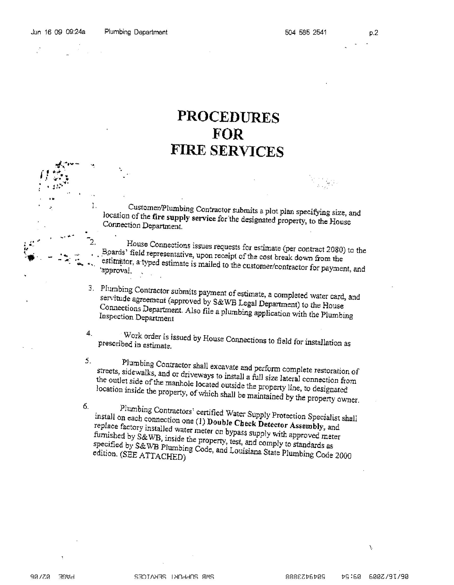
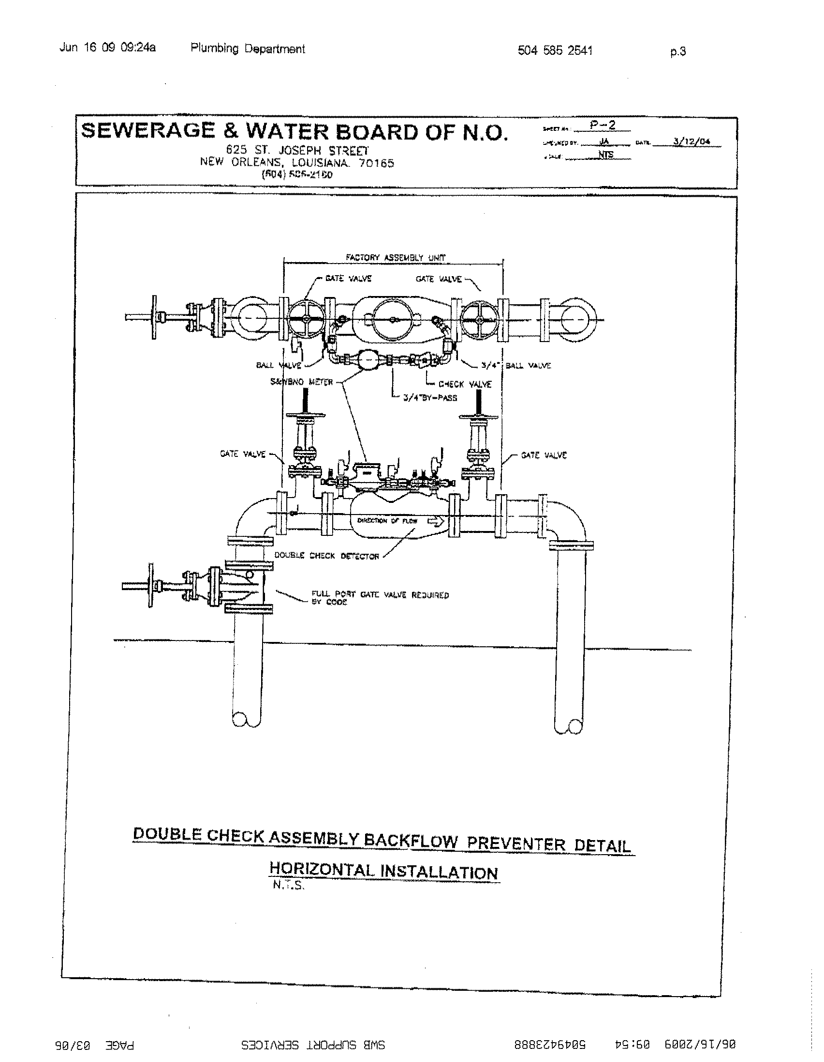
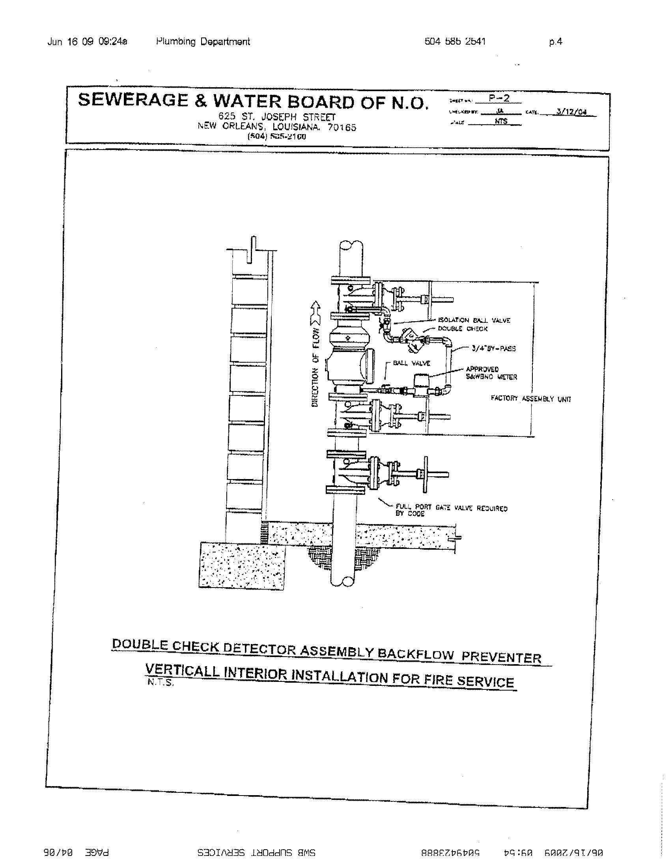
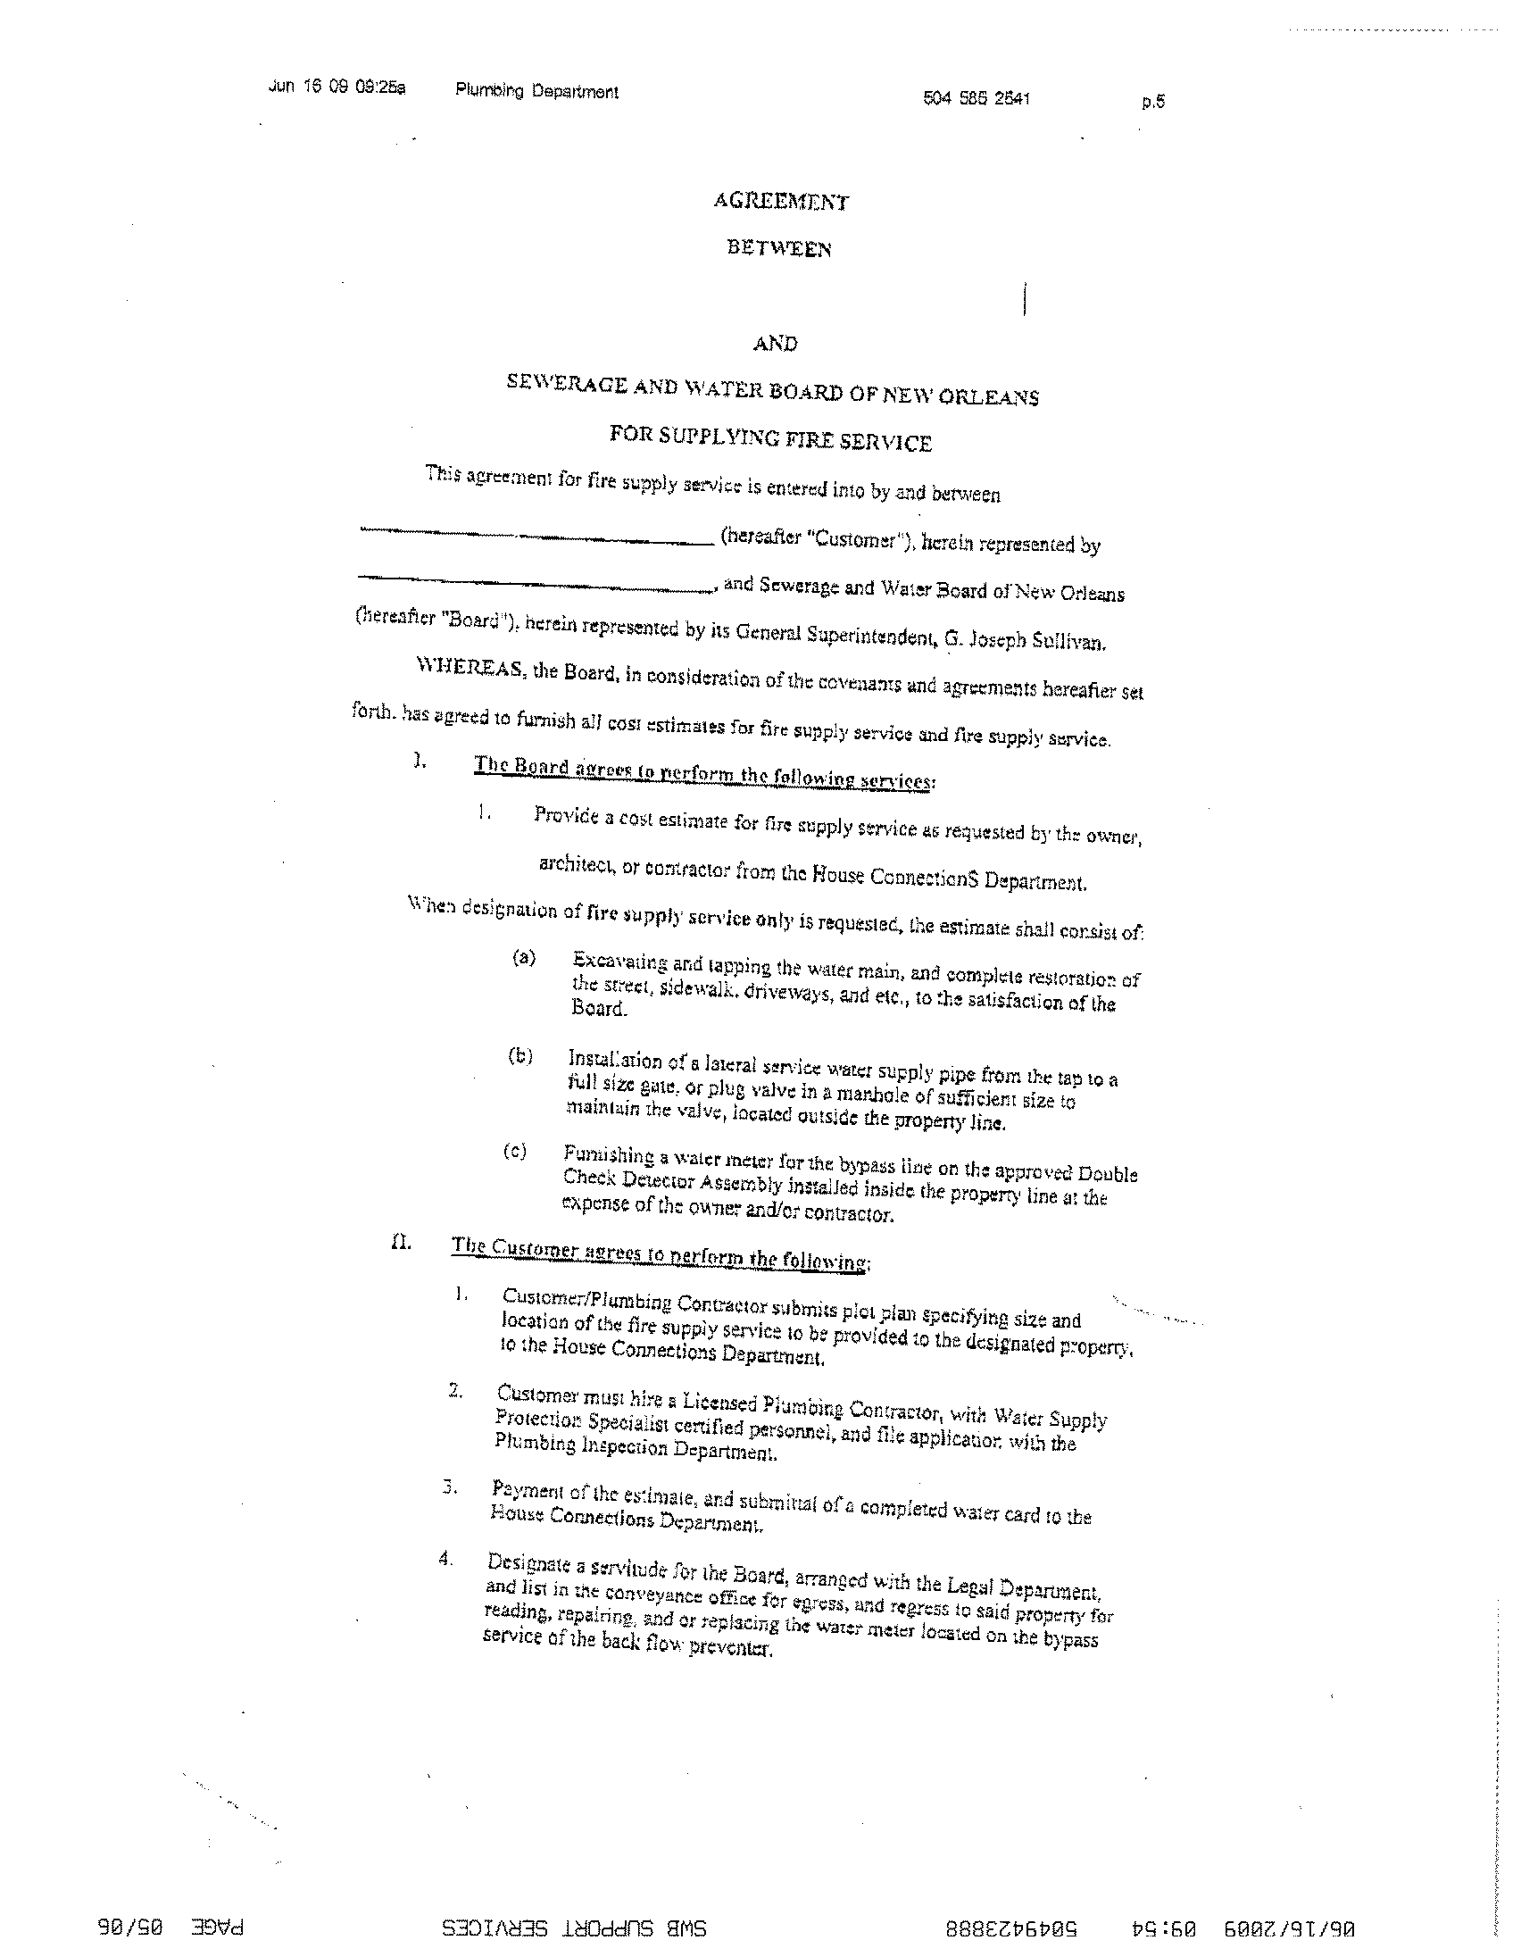
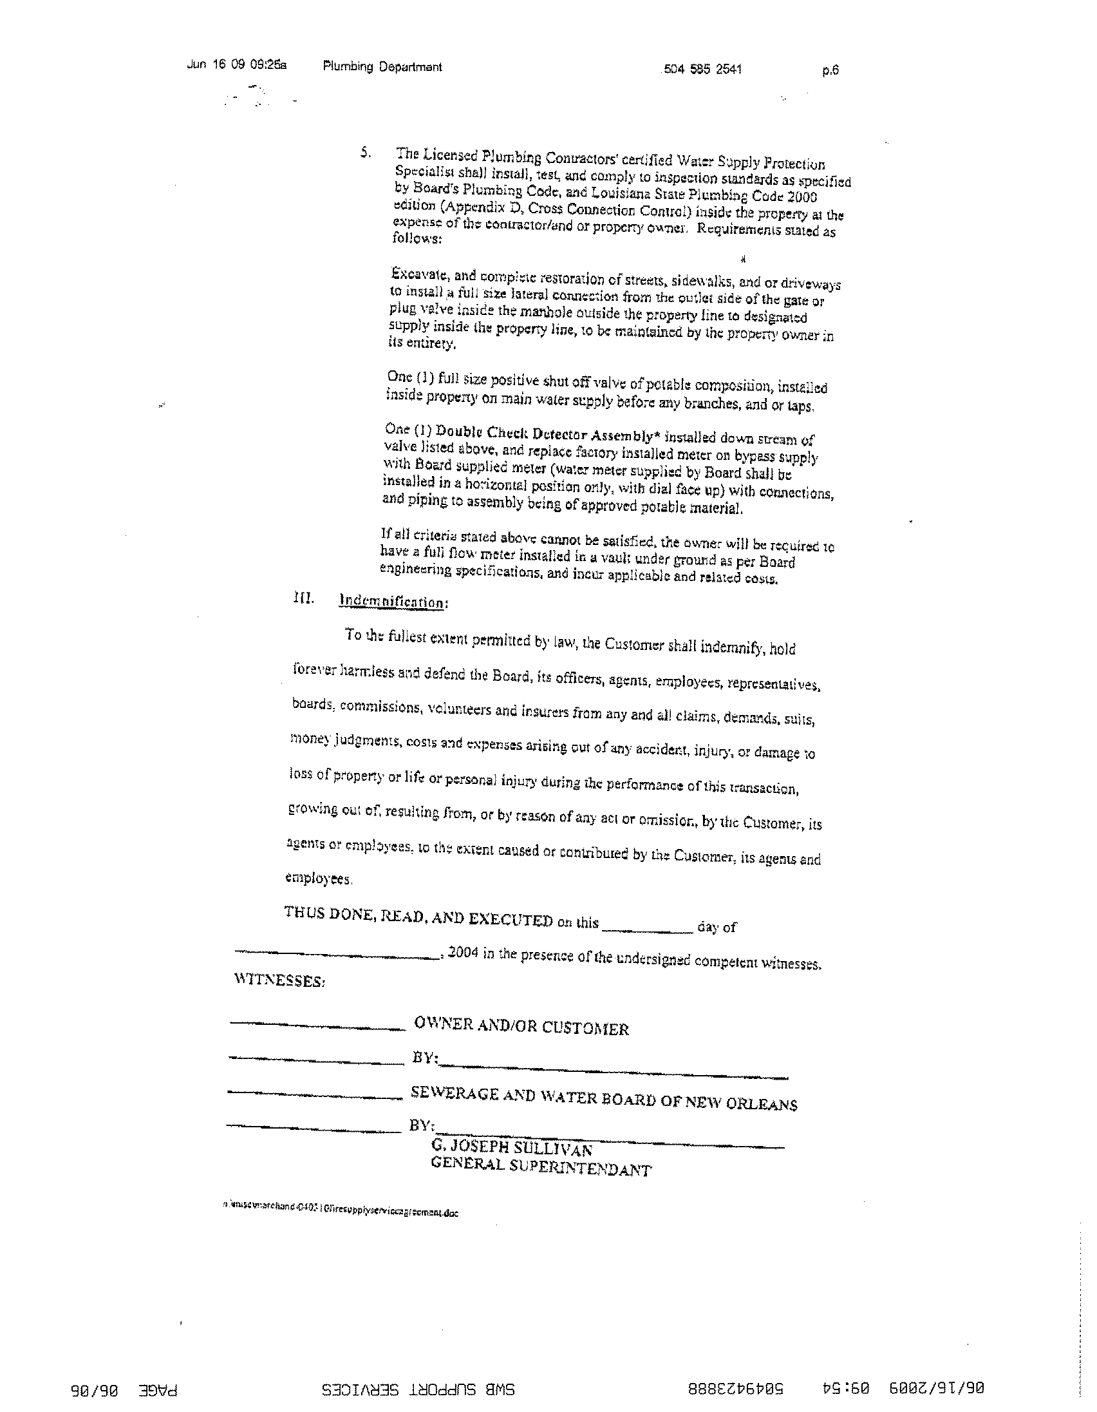
Emergency Planning and Preparedness
Assembly Permits, Capacity/Occupant Load, Fire Evacuation and Fire Safety Plans

Assembly Permits
- Assembly occupancy includes the use of a building or structure, or a portion thereof, for the gathering together of persons for purposes such as civic, social or religious functions; recreation, food or drink consumption; or awaiting transportation with an occupant load more than 50 persons.
- An operational permit is required to operate a place of assembly.
- All required assembly permits shall be renewed annually.
- All assembly occupancies shall have a “Fire Evacuation Plan” and “Fire Safety Plan” available in the workplace for reference and review by employees and copies shall be furnished to the fire code official for review upon request.
- All assembly occupancies shall provide a detailed seating plan, occupant load, and occupant load limit. Deviations from the approved plans shall be allowed provided the occupant load limit for the occupancy is not exceeded and the aisles and exit accessways remain unobstructed.

Capacity/Occupant Load
- Occupant load is the number of persons for which the means of egress of a building or portion thereof is designed.
- Every room or space that is assembly occupancy shall have the occupant load posted in a conspicuous place, near the main exit or exit access doorway. (Posted signs shall be of an approved legible permanent design.
- Contact NOFD-Fire Prevention Division @ 658-4770 or SFM @ 219-4600 to schedule an inspection and obtain a current “Capacity Sign”.
- The maximum occupants allowed per floor area within places of assembly is determined as indicated below:
Assembly without fixed seats:
Standing space 5 net square feet/ person
Concentrated (chairs only-not fixed) 7 net square feet/ person
Unconcentrated (tables and chairs) 15 net square feet/ person

Stages and platforms: 15 net square feet/ person
Business areas: 100 gross square feet/ person

- The minimum number of exits per occupant load is determined as indicated: Occupant load (1-500 persons) minimum 2 exits required
Occupant load (501-1,000 persons) minimum 3 exits required
Occupant load (More than 1,000 persons) minimum 4 exits required

- Bars, restaurants, and similar businesses with an occupant load of less than 50 persons is deemed a “business use” and a single exit is allowed, however, the travel distance and the number of floors may require additional exits.
Fire Evacuation Plans
- Fire evacuation plans shall include the following:
- Emergency egress or escape routes and whether evacuation of the building is to be complete or, where approved, by selected floors or areas only.
- Procedures for employees who must remain to operate critical equipment before evacuating.
- A procedure for accounting for employees and occupants after evacuation has been completed.
- Identification and assignment of personnel responsible for rescue or emergency medical aid.
- The preferred and any alternative means of notifying occupants of a fire or emergency.
- The preferred and any alternative means of reporting fires and other emergencies to the fire department or designated emergency response organization.
- Identification and assignment of personnel who can be contacted for further information or explanation of duties under the plan.
- A description of the emergency voice/alarm communication system alert tone and preprogrammed voice messages, where provided.

Fire Safety Plans
- Fire safety plans shall include the following:
- The procedure for reporting a fire or other emergency.
- The life safety strategy and procedures for notifying, relocating, or evacuation of occupants.
- Site plans indicating the following:
a. The occupancy assembly point.
b. The location of fire hydrants.
c. The normal routes of fire department vehicle access.
4. Floor plans indentifying the locations of the following:
a. Exits
b. Primary evacuations routes.
c. Secondary evacuation routes.
d. Accessible egress routes.
e. Areas of refuge.
f. Manual fire alarm boxes.
g. Portable fire extinguishers.
h. Occupants-use hose stations.
i. Fire alarm annunciators and controls.
5. A list of major fire hazards associated with the normal use and occupancy of the premises, including maintenance and housekeeping procedures.
6. Identification and assignment of personnel responsible for maintenance of systems and equipment installed to prevent or control fires.
7. Identification and assignment of personnel responsible for maintenance, housekeeping and controlling fuel hazard sources.

Emergency Evacuation Drills
- Emergency evacuation drills shall be conducted at least quarterly to familiarize all occupants with the drill procedures.
- Responsibilities for emergency evacuation drills shall be assigned to competent persons designated to exercise leadership.
- Emergency evacuation drills shall be held at unexpected times and under varying conditions to simulate the unusual conditions that occur in case of fire
- Records of emergency evacuation drills shall be maintained and available on the premise and shall include the following:
- Identity of persons conducting the drill.
- Date and time of the drill.
- Notification method used.
- Staff members on duty and participating
- Number of occupants evacuated.
- Special conditions simulated.
- Problems encountered.
- Weather conditions when occupants were evacuated.
- Time required to accomplish complete evacuation.

- Prior notification of emergency evacuation drills shall be given to the fire code official.
- Where a fire alarm system is provided, emergency evacuation drills shall be initiated by activating the fire alarm system.
- As building occupants arrive at the assembly point, efforts shall be made to determine if all occupants have been successfully evacuated or have been accounted for.
- An electrically or mechanically operated signal used to recall occupants after an evacuation shall be separate and distinct from the signal used to initiate the evacuation. The recall signal initiation means shall be manually operated and under control of the person in charge of the premises or the official in charge of the incident. No one shall reenter the premises until authorized to do so by the official in charge.
Inspection and Permit Fee Schedule

105.8 Schedule of Fees for Permits and/or Inspections. Any inspection conducted by an employee of the New Orleans Fire Department shall be subject to the following schedule of inspection fees:
SQUARE FOOTAGE FEE SCHEDULE
MORE THAN  SQ. FT. | LESS THAN  SQ. FT. | INSPECTION  FEE
-0-  10,000  50,000  100,000  150,000  200,000  250,000  300,000  350,000  400,000  450,000  500,000  550,000  600,000  650,000  700,000  750,000  800,000  850,000  900,000  950,000  1,000,000  1,050,000  1,100,000  1,150,000 | 10,000  50,000  100,000  150,000  200,000  250,000  300,000  350,000  400,000  450,000  500,000  550,000  600,000  650,000  700,000  750,000  800,000  850,000  900,000  950,000  1,000,000  1,050,000  1,100,000  1,150,000  1,200,000 | 50.00  75.00  100.00  125.00  150.00  175.00  200.00  225.00  250.00  275.00  300.00  325.00  350.00  375.00  400.00  425.00  450.00  475.00  500.00  525.00  550.00  575.00  600.00  625.00  650.00
For any area in excess of 1,200,000 square feet, add $25.00 for each additional 50,000 square feet or any part thereof as per schedule.
FEES IN ADDITION TO INSPECTION OF PREMISES ARE AS FOLLOWS:
***All permits are renewable annually unless otherwise stated***
Firewatch Administrative Fee | 10% of total firewatch detail cost
Explosive Shipment Transporting  (see late charges) | $50.00 per shipment
**Tents, Tarps, Canopies, or Temporary Membrane Structures (120 sq.ft. or greater) | Per square footage fee schedule, per structure, per event
Blasting Operations | $75.00 per day
Bonfires | $75.00 per day
Paint Burning | $50.00 per day
* 2006 Fire Prevention Code Amendments | $25.00 per packet
Cutting or Welding or Hot Work | $100.00 annually
Plan Review (Exhibit/Exposition, code compliance, fire evacuation, special event, etc.) | Per square footage fee schedule
Photo static copies of files or other records | $1.00 per page single sided
Pyrotechnic Displays  (see late charges) | $100.00 per display
***Pyrotechnic Displays (Seasonal/Annual) | $500.00 per season or annually. Any modification to approved display will be deemed a new display
Class “B” Pyrotechnic License  (NFPA 1123 / Outdoor) | $50.00 annually
Class “C” Pyrotechnic License  (NFPA 1126 / Indoor) | $50.00 annually
Class “D” Flame Effect License | $25.00 annually
Class “B” and “C” | $100.00 annually
NOFD “NO SMOKING” Signs | $5.00 each
Flammable or Combustible Liquid Storage Tank Installation or Removal | $75.00 per tank
Fumigations | Per square footage fee schedule for structures  $25.00 each for shipping containers
Fire Incident Report (Suppression Generated) | $25.00 each
Fire Investigative Report | $50.00
Arson Investigative Report | $100.00
Open Flame Device | $50.00 per month
Outdoor Rubbish Fire / Land Clearing | $75.00 per day
Special Event | Minimum $50.00 per event or as per square footage fee schedule
Mobile and/or Temporary Vendor | $50.00 per vehicle
Any Permit not specifically listed above | Per square footage fee schedule
*Copies of 2006 International Fire Code books may be obtained by contacting 1-888- ICC-SAFE (422-7233)
** Any structure erected for a period greater than 180 days shall comply with applicable sections of International Building Code.
***Seasonal/Annual Pyrotechnic Permits are issued at discretion of fire official for standard repetitive displays.

LATE FEES / CHARGES
Any operation which is commenced without a permit for which a permit is required. | Charges are tripled
Any operation which requires a firewatch, but commence without a firewatch being in place. | Administrative fees are tripled
All annual permits and licenses must be renewed within ten days of expiration date.  Does not include pyrotechnic licenses. | If late, charges are doubled
Pyrotechnic / special effect permits must be applied for at least five working days prior to the display. | If late, charges are doubled
Explosive Shipment permits must be applied for at least 24 hours prior to shipment. | If late, charges are tripled
Fumigation permits must be applied for at least 24 hours prior to fumigation.  Exception: Container fumigation permits must be applied for by 3:00pm the day prior to fumigation. | If late, charges are tripled
Exhibit / Exhibitions plans submitted or re-submitted less than 10 working days of move-in/start of event | Charges are doubled

EXCEPTIONS TO FEES AND CHARGES
- Premises owned and operated by city, state, or federal government. Private contractors operating or providing services within these facilities are NOT EXEMPT.
- Inspection of private residences consisting of two (2) or less units.
- All exceptions or waiver of any fees and charges indicated by this code shall only be made by the Chief Administrative Officer or his/her designee made in writing. Such written exception or waiver shall be made available to the Fire Official prior to the processing of any permits, licenses, or permission of activity required by this code whereby such fee or charge would apply. It shall be the responsibility of person(s) or entities seeking such exceptions or waivers to secure the same.

