LEGAL ADVERTISEMENT

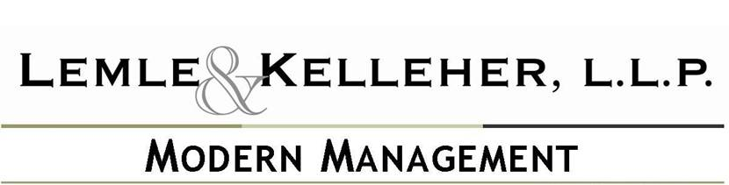

**MARCH 2011**

**SEMINAR INVITATION—SHREVEPORT, LOUISIANA**

Lemle & Kelleher, L.L.P., Gulf States Association of Homes and Services for the Aging, Louisiana Bankers Association, Louisiana Casino Association, Louisiana Hospital Association, and Louisiana Hotel & Lodging Association present a half-day labor and employment law seminar in Shreveport, Louisiana (location to be announced), on Tuesday, April 28, 2011, 8:30 a.m.—12:00 p.m.. Topics include: Harassment Goes Cyberspace, GINA—The Law and Its Impact on ADA and Preparing for Renewed Union Organizing as Recent Labor Board Decisions Encourage Organized Labor. [***Click here***](http://www.lemle.com/news_articles/pdf/ModManagemar11.pdf) to read more.

**ENFORCEMENT GUIDANCE ON PPE ISSUED BY OSHA**

On February 10, 2011, the Occupational Safety and Health Administration issued the Enforcement Guidance for Personal Protective Equipment in General Industry which provides enforcement personnel with instructions on determining employers’ compliance with OSHA personal protective equipment standard. [***Click here***](http://www.lemle.com/news_articles/pdf/ModManagemar11.pdf) to read more.

**THE CASE OF THE FACEBOOK FIRING SETTLES**

The Case viewed as a test case on employees using social media to post work related comments has settled. [***Click here***](http://www.lemle.com/news_articles/pdf/ModManagemar11.pdf) to read more.

**INCENTIVES TO PARTICIPATE IN WELLNESS PROGRAMS**

A recent survey shows financial incentives are being used to encourage employees to participate and engage in wellness programs. [***Click here***](http://www.lemle.com/news_articles/pdf/ModManagemar11.pdf) to read more.

**OLDER AMERICANS STAYING IN THE WORKFORCE**

In 2010, the number of older Americans staying in the workforce hit a 35 year high; roughly 40 percent of Americans age 55 and older were still working. [***Click here***](http://www.lemle.com/news_articles/pdf/ModManagemar11.pdf) to read more